Quick Zoom

Join Zoom website:
- From the Portal use the Zoom tile or from a browser go to https://charlesdarwinuni.zoom.us/
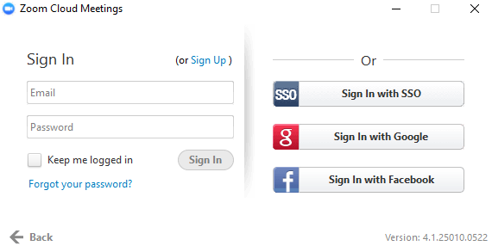
- Click on Join and put in your meeting ID from your invite details
Or
- Click on Zoom Sign In and put in your user name and password when prompted
- Click on the My Meetings tab
- Click on the Meeting link that you want to join
NOTE:
CDU Now has a corporate license for Zoom with no restrictions.

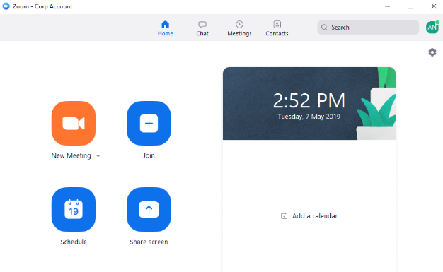
Join Zoom Desktop Client:
- From Desktop - > Open or click on Zoom
- Click on Sign in and then use “Sign in with SSO” and use “charlesdarwinuni” .zoom.us
- Click on Join
- Enter the Meeting ID (Details from your email invitation)
- You can join the meeting with your video or audio enabled or disabled
- When zoom windows starts up select Join Audio Conference by Computer or select Test Computer Mic & Speakers if you have issues.
Join from Email link:
- From your email invitation sent or created by your meeting host
- Click on the link in the email (join via PC, Mac, iOS or Android)
- You will be taken to the meeting created by the host.
Telephone dial in:
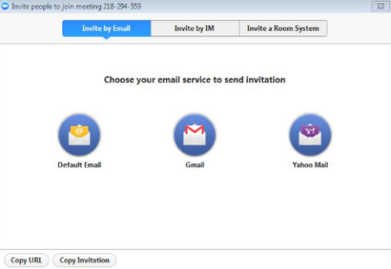
- From your email invite details dial or call the number provided

Schedule Zoom Meetings
- From the Zoom tile in the Portal or via the Website https://charlesdarwinuni.zoom.us/
- Zoom app from your desktop when downloaded

Schedule meeting from the Zoom website:
- Login to the Zoom via the portal or the Zoom website https://charlesdarwinuni.zoom.us/
- Click on Zoom Sign In
- Click on Sign in and then use “Sign in with SSO” and use “charlesdarwinuni” .zoom.us
- Click on the Meetings tab
- Click on Schedule a New Meeting
- Complete the details of your meeting
- Click on Schedule
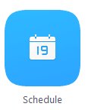
- You can then add your meeting to your Outlook calendar to invite other participants

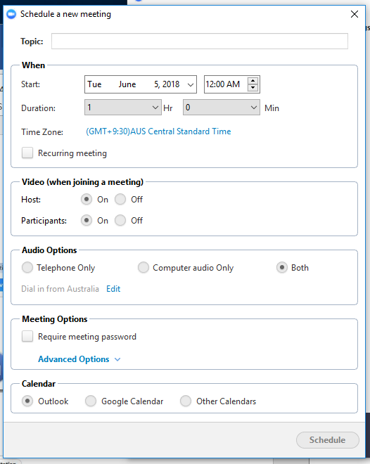
Schedule meeting from app:
- Open and log into your Zoom app
- Click on Sign in and then use “Sign in with SSO” and use “charlesdarwinuni” .zoom.us
- Click on the Schedule icon
- The Schedule a meeting window will open
- Complete the required details of your meeting
- When you click on schedule, your meeting will be placed into a meeting request
- You can then manually add your participants

More info
Zoom Video Tutorials https://support.zoom.us/hc/en-us/articles/206618765-Zoom-Video-Tutorials
How to Start and Join https://support.zoom.us/hc/en-us/sections/201728913-Joining-Starting
Zoom Video Layout https://support.zoom.us/hc/en-us/articles/201362323-How-Do-I-Change-The-Video-Layout-

